Article

MosicaFormer: A Novel approach for Remote Sensing Spatio-temporal Data Fusion for lake water monitor

Dongxue Zheng 1, 2, Aifeng Lv1,*

|  |
| --- |
| Academic Editor: Firstname Lastname  Received: date  Revised: date  Accepted: date  Published: date  **Citation:** To be added by editorial staff during production.  **Copyright:** © 2025 by the authors. Submitted for possible open access publication under the terms and conditions of the Creative Commons Attribution (CC BY) license (https://creativecommons.org/licenses/by/4.0/). |

1 Key Laboratory of Water Cycle and Related Land Surface Processes, Institute of Geographic Sciences and Natural Resources Research, Chinese Academy of Sciences, Beijing 100101, China

2 University of Chinese Academy of Sciences, Beijing 100049, China

**\*** Correspondence: e-mail@e-mail.com

**Abstract:** Lake water is a crucial resource in the global hydrological cycle, providing substantial freshwater resources and regulating regional climates. High-resolution remote sensing satellites, such as Landsat, provide unprecedented opportunities for continuous monitoring of lake area changes. However, limitations imposed by revisit cycles and cloud cover often result in only a few usable images per month for a single lake, restricting our understanding of daily-scale lake dynamics. Leveraging recent advancements in AI-driven remote sensing technologies, we developed an innovative deep learning algorithm, MosicaFormer, to integrate observations from MODIS and Landsat, producing seamless daily Landsat-scale images. This approach combines Masked Autoencoders with the Swin Transformer architecture, effectively capturing latent relationships between images. Testing on public benchmarks demonstrates that our method outperforms all traditional approaches, achieving a robust data fusion with overall R² of 0.74. A case study on lake water monitoring reveals that our method captures daily variations in the surface area of Hala Lake, providing accurate and robust results. The results indicate that our method demonstrates significant advantages and holds substantial potential for large-scale remote sensing-based environmental monitoring.

**Keywords:** Lake water; Data fusion; Landsat, Transformer

1. Introduction

[先介绍湖泊重要性]湖泊是水圈的重要组成部分，是生物圈、大气圈和岩石圈在物质循环和能量转移方面相互作用的枢纽，湖泊面积的变化反映了全球气候和环境的变化 [1]。然而，由于气候变化和人类活动，湖泊发生了巨大变化，有研究显示湖泊面积和湖水储量正在下降[2]。水体动态的监测变得尤为重要。随着遥感(RS)和地理信息技术(GIS、GPS)的发展和应用，可以采用一些有效的技术手段对大空间区域湖泊水体的动态变化进行监测 [3]。

[湖泊监测的局限]快速变化的内陆水域对传感器的空间和时间分辨率都有严格的要求。Some High-resolution optical satellite time series data, with both fine spatial and temporal detail, are essential for accurate modeling and monitoring of dynamics of surface water bodies. However, a key limitation arises from the inherent tradeoff between spatial resolution and temporal revisit rates, which restricts the satellites' capacity to capture the Earth's surface in high spatiotemporal resolution [4]. For example, the Moderate Resolution Imaging Spectroradiometer (MODIS), a widely used sensor, provides images with resolutions ranging from 250m to 1000m. While this resolution may not be sufficient for accurately mapping water bodies, it offers daily image coverage. On the other hand, Landsat, which has the longest continuous space-based observation data since the 1970s, provides 30m spatial resolution images[5]. However, its 16-day revisit cycle and frequent cloud cover limit its utility for capturing rapid changes in surface water change[6]. 对于湖泊监测来说，日尺度的持续观测有助于我们了解水文过程并加深对当地水循环的认知。为了解决这个问题，需要将高空间分辨率低时间分辨率的Landsat进行融合，从而导出日尺度连续的高分辨率影像。图1展示了图像融合的概念示意。

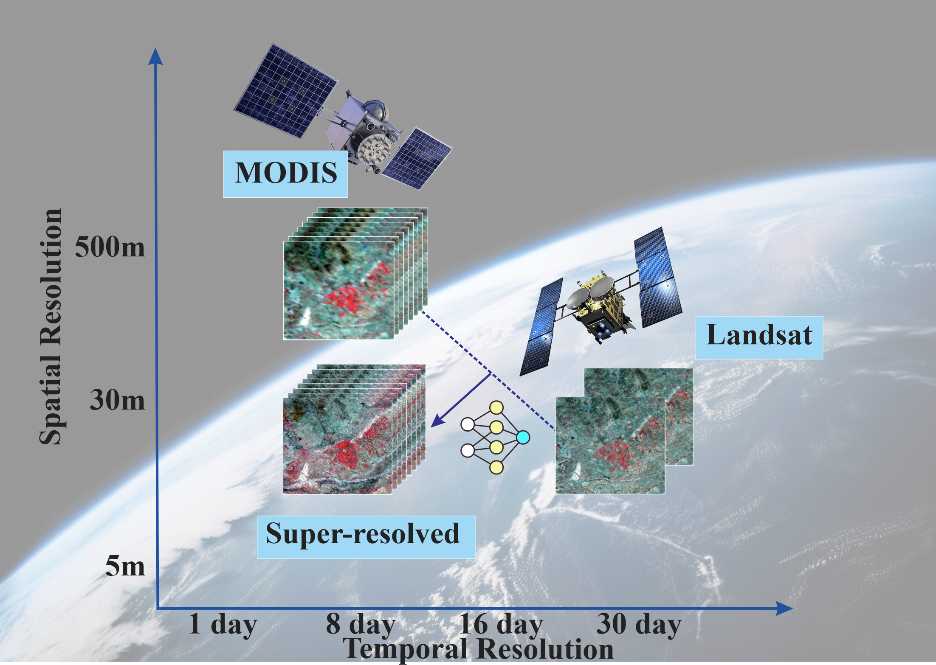

**Figure 1.** This is a figure. Schemes follow the same formatting.

To address this issue, previous research has proposed spatiotemporal fusion (STF) methods that improve spatiotemporal resolution by merging high-spatial-resolution images, which are temporally sparse, with low-spatial-resolution images that are captured more frequently, to obtain more accurate information on water body dynamics.

Generally, STF methods are pursued through four main approaches: the spatiotemporal weighting function methods, as represented by the spatial and temporal adaptive reflectance fusion model (STARFM) [4], wavelet transformation [7, 8], unmixing-based data fusion [9], sparse representation [10, 11] and machine learning methods [12]. 各种STF算法已在spatiotemporal data augmentation of water bodies有了广泛的应用。具体来说，STF用于生成类似 Landsat 的多光谱图像，然后使用无监督、监督或基于对象的分类算法对其进行处理以得出地表水图 [13-17]。Among the various data fusion techniques, STARFM and its derivatives (ESTARFM) are likely the most widely used algorithms for generating synthetic surface reflectance with both high spatial and temporal resolutions, owing to their reliable prediction performance [18]. STARFM identifies similar neighborhoods for the target pixel and makes predictions by weighting these neighborhoods based on spatial, spectral, and temporal proximity, while ignoring the mixture and changes in land cover types in the coarse resolution pixels. However, STARFM faces several issues: first, it struggles to address abnormal cases involving land-cover type changes or disturbance events not captured in a single Landsat image; second, it is less effective in making predictions in heterogeneous landscapes. Subsequently, many studies have suggested improvements to the STARFM algorithm, and several modified models of STARFM have been proposed. Hilker, et al. [19] introduced the Spatial and Temporal Adaptive Algorithm for Reflectance Change Mapping (STAARCH), which identifies temporal variations using a dense set of MODIS data. ESTARFM, which was proposed by Zhu, et al. [20], introduced several improvements over the original STARFM algorithm, with the most notable being the use of a conversion coefficient to enhance prediction accuracy in heterogeneous landscapes. Wang, Liu, Li, He and Zheng [3]使用ESTARFM模型融合Landsat与MODIS影像后，提取湖泊水体，探究近20年来湖泊水位变化关系。Dao, Mong and Chan [14]同样使用ESTARFM生成无云Landsat/MODIS 合成数据，用于划定洪水期间的淹没区域。Li, et al. [21] 提出了STSWM方法，除了MODIS-Landsat影像对之外，还使用surface water occurrence (SWO) 和 DEM提供水面以上和水面以下的地形信息，生成了30m空间分辨率的地表水图，可检测到由于云层覆盖和数据缺乏地区的地表水变化。

随着深度学习在近年的流行，基于学习的时空融合方法也随之出现。Song, et al. [22]提出了一种基于卷积神经网络（CNN）的时空融合模型，通过学习MODIS和下采样Landsat影像之间的端到端映射来自动提取有效的影像特征。然而这种方法仅使用了3个隐藏层，难以准确模拟MODIS和Landsat影像之间复杂的非线性对应关系。为了改进这种浅层模型，Zheng, et al. [23]提出了新的基于超深卷积神经网络（VDCN）的方法，在低空间分辨率的MODIS和Landsat数据之间训练了一个非线性映射VDCN。最近，Filali Boubrahimi, et al. [24]提出了一种新的基于机器学习的方法（Hydro-GAN）将低分辨率 MODIS 数据映射到高分辨率 Landsat-8 图像时提高边界精度，提高了生成水体多边形的准确性。近期随着人工智能AI方法的兴起，为遥感图像融合提取了前所未有的机遇【补充ResNet、GAN、Transformer在遥感图像超分辨率融合的进展】

**Table 1. Summary of recent remote sensing data fusion method**

|  |  |  |  |  |  |  |
| --- | --- | --- | --- | --- | --- | --- |
| **Title 1** | **Type** | **Target resolution** | **Spatial**  **interpolation** | **Temporal**  **gap filling** | **Input data (revisit frequency)** | **Reference** |
| STARFM | Weight function–based method | 30m; daily | N/A | √ | MODIS (MOD09GHK; daily), Landsat (Landsat-7ETM+; 16 days) | 如Zhang et al., 2020 |
| Semi-physical model | Semi-physical fusion approach | 30m; daily | √ | N/A | MODIS (MODIS BRDF/Albedo; 16 days), Landsat (Landsat ETM+ L1G; 16 days) |  |
| STAARCH | Hybrid method (weight function-based and unmixing method) | 30m; 8 days | N/A | √ | MODIS (MOD09/MYD09; 8 days), Landsat (Landsat ETM; 16 days) |  |
| ESTARFM | Weight function–based method | 30m; daily | √ | N/A | MODIS (MOD09GQ; daily), Landsat (Landsat 8 OLI C1 Level 2; 16 days) |  |
| STRUM | Hybrid method (weight function-based and unmixing method) | 30m; daily | √ | N/A | MODIS (MODIS MCD43A4 BRDF; 8 days), Landsat (Landsat 8 OLI; 8 days) |  |
| FSDAF | Hybrid method (weight function-based and unmixing method) | 30m | √ | N/A | MODIS (MOD09GA Collection 5; daily), Landsat (Landsat 7 ETM +; 16 days) |  |
| RASTFM | Weight function–based method | 30m | √ | √ | MODIS (MOD09; 8 days), Landsat (Landsat-7; 16 days) |  |
| VDCNSTF | Deep learning–based method | 30m | √ | √ | MODIS (MOD09GA Collection 5; daily), Landsat (Landsat-5 TM; 16 days) |  |
| VIPSTF | Hybrid method (weight function-based and unmixing method) | 30m | √ | √ | MODIS (MOD09GA Collection 5; daily), Landsat (Landsat 7 ETM+; 16 days) |  |
| STAIR | Weight function–based method | 30m | √ | √ | MODIS (MCD43A4; daily), Landsat (Landsat 7 and 8 Level 2; 16 days) |  |
| STSWM | Hybrid method (weight function-based and unmixing method) | 30m; 8 days | N/A | N/A | MODIS (MOD09A1; 8 days), Landsat (Landsat 7 and 8 Level 2; 16 days) |  |
| MosicaFormer | Masked Autoencoders with the Swin Transformer architecture | 30m; daily | √ | √ | MODIS (MOD09GA Collection 5; daily); Landsat (Landsat 8 OLI; 8 days) | This study |

In this study, we leverage the capabilities of a novel Transformer-based deep learning model and the innovative concept of Masked Autoencoders to advance remote sensing data fusion, proposing a new model named MosicaFormer. This work represents the first integration of Masked Autoencoders with Transformers for remote sensing image fusion. We introduce a novel concept, "less is more," which involves the random masking of low-frequency information during the encoding phase using Masked Autoencoders. This counterintuitive approach enhances the efficiency of neural network learning, particularly for image super-resolution tasks where input images inherently possess lower resolutions. By discarding low-frequency information, the network is guided to focus on learning higher-frequency features more effectively. Tests on publicly available image fusion benchmarks demonstrate that our method surpasses all traditional and commonly used deep learning approaches. Furthermore, a case study on lake surface area monitoring highlights the method’s potential for applications in hydrology and large-scale remote sensing-based ecological monitoring.

2. Materials and Methods

2.1. Data

Landsat and MODIS remote sensing data were fused to achieve enhanced image resolution and temporal coverage. The high-resolution dataset comprises Landsat-8 OLI images with a spatial resolution of 30 m and six spectral bands, including the blue band (0.45-0.51 μm), the green band (0.53-0.59 μm), the red band (0.64-0.67μm), the near-infrared band (0.85-0.88μm), the short-wave infrared-1 band (1.57-1.65μm), and the short-wave infrared-2 band (2.11-2.29μm). The coarse-resolution dataset consists of MODIS09GA images with a spatial resolution of 500 m. The bands from MODIS images were selected and reordered to align with the corresponding Landsat bands for data fusion. During both the testing phase and the lake application stage, the same data sources were utilized, maintaining consistent band selection but varying image sizes and regions. Table 2 provides a detailed summary of the benchmark dataset and the lake water dataset.

**Table 1. Summary of two remote sensing dataset in this study**

|  |  |  |  |  |
| --- | --- | --- | --- | --- |
| Dataset | Image size | Data pairs | Timespan | Description |
| Benchmark | 2480×2800×6 | 27 | 2013-5-30 to 2018-12-06 | Rural areas for model evaluating |
| Lake | 2000×1200×6 | 12 | 2017-01-01 to 2017-12-31 | A lake for model application |

2.2. Model design

Our MosicaFormer model draws inspiration from integrates MAE with the Swin-Transformer. The structure of the model is illustrated in Figure 2. It comprises an encoder section that incorporates an improved MAE encoder and a Vector Quantized Variational Autoencoder (VQ-VAE) encoder. The MAE encoder processes input images by encoding them into tokens and randomly masking certain windows, as shown in Figure 2a. Subsequently, the VQ-VAE encoder maps these tokens into a high-dimensional latent space. The input image dimensions are B×6×H×W (batch×band×height×width). After processing through the VQ-VAE encoder, the image is divided into fixed-size patches, and the channel number *C* is converted to 64. A 4 × 4 convolution kernel with no overlapping regions is applied, using a stride of 4. Following the encoding stage, the model applies the Swin-Transformer with integrated MAE. During this phase, a standard Swin-Transformer block processes the masked windows. In the Window Multi-head Self-Attention (W-MSA) and Shifted Window Multi-head Self-Attention (SW-MSA) stages, attention is calculated within individual patches and across sliding windows to capture inter-window relationships. The attention mechanism is proposed by Vaswani et al. (2017), operates by transforming the input patch matrix Y into query matrix ($Q_{h}=YW_{h}^{Q}$), a key matrix ($K_{h}=YW_{h}^{K}$), and a value matrix ($V_{h}=YW_{h}^{V}$), where *h=1,…,H* denotes *H* distinct sets if *Q, K,* and *V* matrices. The parameters $W_{h}^{Q}$, $W_{h}^{K}$, and $W_{h}^{V}$ are learnable. The attention output *Oh* is calculated as the dot product of the query and key matrices, scaled and weighted by the value matrix, as follows:

$$O_{h}=Attention\left(Q_{h}, K_{h},V_{h}\right)=softmax\left(\frac{Q_{h}K_{h}^{T}}{\sqrt{d_{k}}}⋅M\right)V_{h}$$

where *M* is an adjustment parameter utilized to filter out rightward attention, *dk* is the dimensionality of the key vectors. Subsequently, *Oh* values are directed to a linear layer following the attention output. Following the encoding and processing stages, the data undergoes an upscaling phase to restore the original resolution. This stage resembles the structure of a U-Net, incorporating skip connections to retain detailed spatial information from earlier layers. After applying the skip connections, the data dimensions become B×128×H/4×W/4. Subsequently, the model utilizes the VQ-VAE decoder to reconstruct the data back to its original resolution, resulting in an output with dimensions B×6×H×W. Figure 2d illustrates the structure of the Swin-Transformer, while Figure 2e presents the integration of MAE with the Swin-Transformer. Additionally, Figure 2f provides a visual representation of the masked window concept, showcasing how the model leverages masked regions for efficient learning and reconstruction.

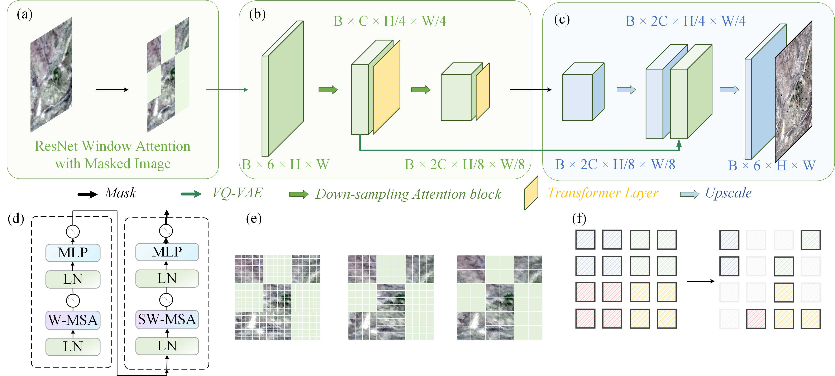

**Figure 2.** Model structure of MosicaFormer

2.3. Training and evaluation strategy

The MosicaFormer model processes data in batches (B = 1), with each batch consisting of six bands as three-dimensional input. The high-resolution Landsat remote sensing images from the same region serve as the target output for training. The benchmark dataset comprises a total of 27 image pairs (27 input MODIS images and 27 corresponding Landsat target images). These images are sorted chronologically, with the first 21 pairs used for training, the subsequent 3 pairs for validation, and the final 3 pairs for testing. This division results in a training, validation, and testing set ratio of approximately 8:1:1. All evaluation results are reported exclusively on the testing set. For the lake monitoring data, the same splitting strategy as the benchmark dataset is applied.

To train the model efficiently and ensure a fair comparison, the primary evaluation metric used is Mean Squared Error (MSE). This metric assesses the model’s overall capability in accurate data fusion without emphasizing specific bands, including the three bands commonly visualized. The loss function used for evaluation is defined as follows:

$$L_{fmse}=\frac{1}{N}\sum_{i=1}^{N}{{(X_{i,j}-{\hat{X}}_{i,j})}^{2}}$$

In this context, $X_{i,j}$ and ${\hat{X}}_{i,j}$ represent the actual and predicted values of the remote sensing images, respectively. The loss function *Lfmse* is designed to quantify the model's ability to recover fine-resolution images effectively. The model optimization is performed using the Adam optimization algorithm, with an initial learning rate of 1.0 × 10−4. A cosine decay strategy is employed to adjust the learning rate dynamically during training. The training process is conducted on a high-performance H800 GPU with 80 GB of memory, offering substantial computational capacity to manage the billions of parameters in the Swin-Transformer architecture.

We assessed two metrics, Root Mean Square Error (RMSE) and Determination score (R2), defined as follows:

请帮我补充RMSE和R2公式

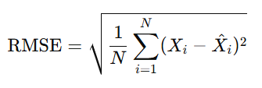

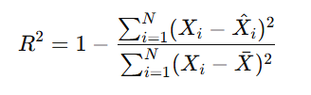

where ${\overline{X}}_{i,j}$ is the mean of the actual values *Xi*. The R2 score reflects how well the model explains the variance in the data, with values closer to 1 indicating better performance.

For evaluating the MosicaFormer model performance, we define the improvement as the R² increasing percentage from benchmark data. For a comprehensive comparison with the benchmark, we also examine the recent widely tested and outperformed super-resolution models: SwinIR and SRGAN. SwinIR is based on the Swin Transformer architecture, which utilizes a hierarchical Transformer framework with shifted windows to model local and global dependencies efficiently. It excels in high-resolution image restoration tasks by combining advanced attention mechanisms and multi-scale feature representation. SRGAN, on the other hand, is based on a Generative Adversarial Network (GAN) framework, where a generator creates high-resolution images from low-resolution inputs and a discriminator ensures realism by distinguishing between real and generated images.

3. Results

3.1. Evaluation on the benchmark dataset

Please help me add description. 看图说话. Any questions feel free to ask me. 可以参考我写的详细图题。

Our implementation of MosicaFormer on the benchmark test dataset allows for a comprehensive comparison with the latest models and the benchmark data. Figure 3 presents ……

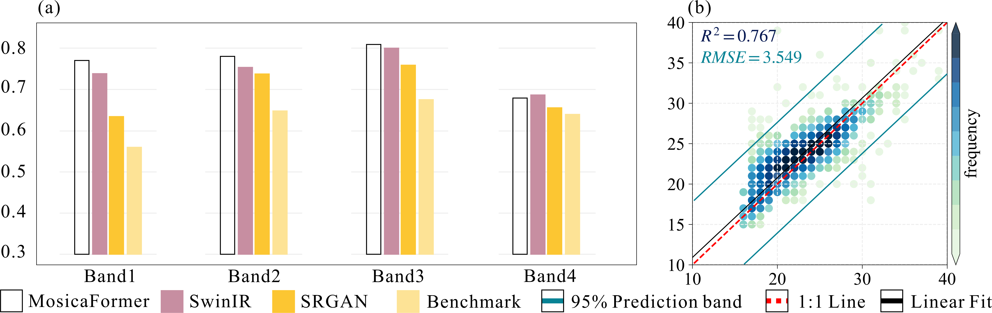

**Figure 3.** Comparison and validation stage. (a) Comparison with benchmark (yellow) and widely tested and outperformed super-resolution models, SwinIR (pink) and SRGAN (dark yellow). (b) Scatter density diagrams and prediction accuracy with different image band versus Landsat ground truth. The blue line represents 95% confidence intervals (upper and lower whiskers) of R2 and RMSE.

3.2. Spatial fusion map

Then we would transfer to see the spatial fusion map results compared to the ground truth. xxxxxxx

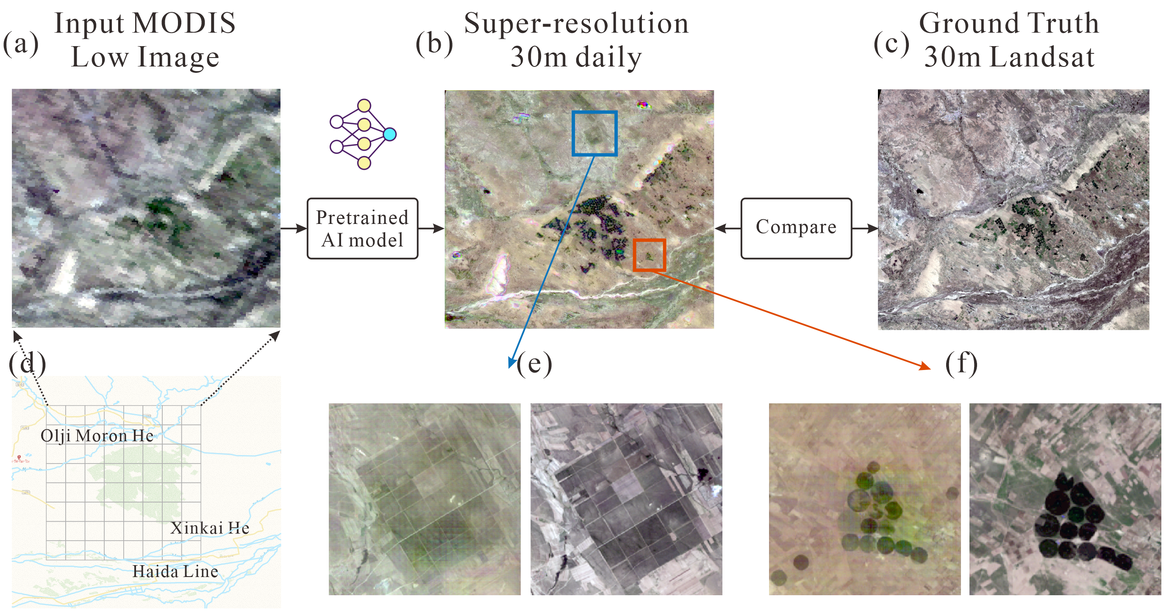

**Figure 4.** The spatial fusion map results compared to the ground truth. (a) The input low-resolution MODIS image used as the initial input for the spatial fusion process. (b) The high-resolution image generated by the pretrained AI model, MosicaFormer, showcasing its ability to produce fine spatial details. (c) The ground truth Landsat image, representing the target high-resolution data for comparison. (d) The benchmark dataset location, indicating the specific region used for testing and evaluation. (e) & (f) Two detailed examples highlighting the super-resolution results

3.3. Application in lake area

A simple regional application case is presented using our MosicaFormer model. Harahu Lake, located in [provide location details], is a representative case of a hydrological area with limited or no observational data.

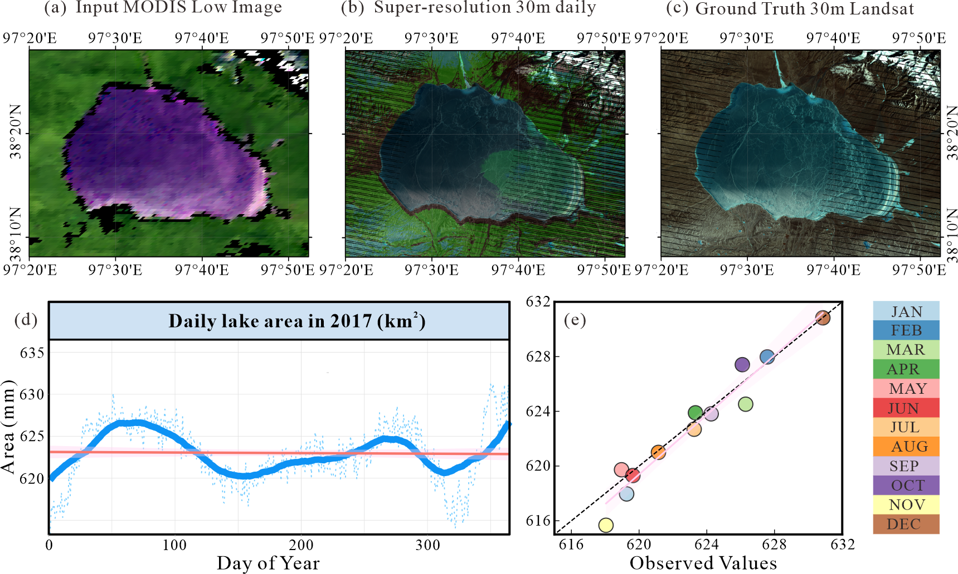 **Figure 5.** A simple regional application case is lake water tracking. (a) The input low-resolution MODIS image in Hala Lake. (b) The high-resolution image generated by the pretrained AI model, MosicaFormer. (c) The ground truth Landsat image. (d) The daily high-resolution images produced by MosicaFormer, with water surface areas extracted using the Otsu algorithm. (e) A comparison of monthly water surface areas for 2017, derived from true Landsat observations and the MosicaFormer-generated results, showcasing the model's accuracy in replicating observed variations.

4. Discussion

Authors should discuss the results and how they can be interpreted from the perspective of previous studies and of the working hypotheses. The findings and their implications should be discussed in the broadest context possible. Future research directions may also be highlighted.

5. Conclusions

This section is not mandatory but can be added to the manuscript if the discussion is unusually long or complex.

**Author Contributions:** For research articles with several authors, a short paragraph specifying their individual contributions must be provided. The following statements should be used “Conceptualization, X.X. and Y.Y.; methodology, X.X.; software, X.X.; validation, X.X., Y.Y. and Z.Z.; formal analysis, X.X.; investigation, X.X.; resources, X.X.; data curation, X.X.; writing—original draft preparation, X.X.; writing—review and editing, X.X.; visualization, X.X.; supervision, X.X.; project administration, X.X.; funding acquisition, Y.Y. All authors have read and agreed to the published version of the manuscript.” Please turn to the [CRediT taxonomy](https://img.mdpi.org/data/contributor-role-instruction.pdf) for the term explanation. Authorship must be limited to those who have contributed substantially to the work reported.

**Funding:** Please add: “This research received no external funding” or “This research was funded by NAME OF FUNDER, grant number XXX” and “The APC was funded by XXX”. Check carefully that the details given are accurate and use the standard spelling of funding agency names at https://search.crossref.org/funding. Any errors may affect your future funding.

**Data Availability Statement:** We encourage all authors of articles published in MDPI journals to share their research data. In this section, please provide details regarding where data supporting reported results can be found, including links to publicly archived datasets analyzed or generated during the study. Where no new data were created, or where data is unavailable due to privacy or ethical restrictions, a statement is still required. Suggested Data Availability Statements are available in section “MDPI Research Data Policies” at https://www.mdpi.com/ethics.

**Acknowledgments:** In this section, you can acknowledge any support given which is not covered by the author contribution or funding sections. This may include administrative and technical support, or donations in kind (e.g., materials used for experiments).

**Conflicts of Interest:** Declare conflicts of interest or state “The authors declare no conflicts of interest.” Authors must identify and declare any personal circumstances or interest that may be perceived as inappropriately influencing the representation or interpretation of reported research results. Any role of the funders in the design of the study; in the collection, analyses or interpretation of data; in the writing of the manuscript; or in the decision to publish the results must be declared in this section. If there is no role, please state “The funders had no role in the design of the study; in the collection, analyses, or interpretation of data; in the writing of the manuscript; or in the decision to publish the results”.

Abbreviations

The following abbreviations are used in this manuscript:

|  |  |
| --- | --- |
| MDPI | Multidisciplinary Digital Publishing Institute |
| DOAJ | Directory of open access journals |
| TLA | Three letter acronym |
| LD | Linear dichroism |

Appendix A

Appendix A.1

The appendix is an optional section that can contain details and data supplemental to the main text—for example, explanations of experimental details that would disrupt the flow of the main text but nonetheless remain crucial to understanding and reproducing the research shown; figures of replicates for experiments of which representative data is shown in the main text can be added here if brief, or as Supplementary data. Mathematical proofs of results not central to the paper can be added as an appendix.

**Table A1.** This is a table caption.

|  |  |  |
| --- | --- | --- |
| **Title 1** | **Title 2** | **Title 3** |
| entry 1 | data | data |
| entry 2 | data | data 1 |

Appendix B

All appendix sections must be cited in the main text. In the appendices, Figures, Tables, etc. should be labeled starting with “A”—e.g., Figure A1, Figure A2, etc.

References

References must be numbered in order of appearance in the text (including citations in tables and legends) and listed individually at the end of the manuscript. We recommend preparing the references with a bibliography software package, such as EndNote, ReferenceManager or Zotero to avoid typing mistakes and duplicated references. Include the digital object identifier (DOI) for all references where available.

Citations and references in the Supplementary Materials are permitted provided that they also appear in the reference list here.

In the text, reference numbers should be placed in square brackets [ ] and placed before the punctuation; for example [1], [1–3] or [1,3]. For embedded citations in the text with pagination, use both parentheses and brackets to indicate the reference number and page numbers; for example [5] (p. 10), or [6] (pp. 101–105).

1. Author 1, A.B.; Author 2, C.D. Title of the article. *Abbreviated Journal Name* **Year**, *Volume*, page range.
2. Author 1, A.; Author 2, B. Title of the chapter. In *Book Title*, 2nd ed.; Editor 1, A., Editor 2, B., Eds.; Publisher: Publisher Location, Country, 2007; Volume 3, pp. 154–196.
3. Author 1, A.; Author 2, B. *Book Title*, 3rd ed.; Publisher: Publisher Location, Country, 2008; pp. 154–196.
4. Author 1, A.B.; Author 2, C. Title of Unpublished Work. *Abbreviated Journal Name* year, *phrase indicating stage of publication (submitted; accepted; in press)*.
5. Author 1, A.B. (University, City, State, Country); Author 2, C. (Institute, City, State, Country). Personal communication, 2012.
6. Author 1, A.B.; Author 2, C.D.; Author 3, E.F. Title of Presentation. In Proceedings of the Name of the Conference, Location of Conference, Country, Date of Conference (Day Month Year).
7. Author 1, A.B. Title of Thesis. Level of Thesis, Degree-Granting University, Location of University, Date of Completion.
8. Title of Site. Available online: URL (accessed on Day Month Year).

**Disclaimer/Publisher’s Note:** The statements, opinions and data contained in all publications are solely those of the individual author(s) and contributor(s) and not of MDPI and/or the editor(s). MDPI and/or the editor(s) disclaim responsibility for any injury to people or property resulting from any ideas, methods, instructions or products referred to in the content.

参考文献

1. Yamazaki, Dai, Mark A. Trigg, and Daiki Ikeshima. "Development of a Global ~90m Water Body Map Using Multi-Temporal Landsat Images." *Remote sensing of environment* 171 (2015): 337-51.

2. Yao, Fangfang, Ben Livneh, Balaji Rajagopalan, Jida Wang, Jean-François Crétaux, Yoshihide Wada, and Muriel Berge-Nguyen. "Satellites Reveal Widespread Decline in Global Lake Water Storage." *Science* 380, no. 6646 (2023): 743-49.

3. Wang, Ziyuan, Xingyue Liu, Wei Li, Shuqiang He, and Tingdan Zheng. "Temporal and Spatial Variation Analysis of Lake Area Based on the Estarfm Model: A Case Study of Qilu Lake in Yunnan Province, China." *Water* 15, no. 10 (2023): 1800.

4. Feng, Gao, J. Masek, M. Schwaller, and F. Hall. "On the Blending of the Landsat and Modis Surface Reflectance: Predicting Daily Landsat Surface Reflectance." *IEEE Transactions on Geoscience and Remote Sensing* 44, no. 8 (2006): 2207-18.

5. Roy, D. P., M. A. Wulder, T. R. Loveland, Woodcock C.E, R. G. Allen, M. C. Anderson, D. Helder, J. R. Irons, D. M. Johnson, R. Kennedy, T. A. Scambos, C. B. Schaaf, J. R. Schott, Y. Sheng, E. F. Vermote, A. S. Belward, R. Bindschadler, W. B. Cohen, F. Gao, J. D. Hipple, P. Hostert, J. Huntington, C. O. Justice, A. Kilic, V. Kovalskyy, Z. P. Lee, L. Lymburner, J. G. Masek, J. McCorkel, Y. Shuai, R. Trezza, J. Vogelmann, R. H. Wynne, and Z. Zhu. "Landsat-8: Science and Product Vision for Terrestrial Global Change Research." *Remote sensing of environment* 145 (2014): 154-72.

6. Sun, Chao, Jialin Li, Yongchao Liu, Tingting Pan, Ke Shi, and Xinyao Cai. "Synthesizing Landsat Images Using Time Series Model-Fitting Methods for China’s Coastal Areas against Sparse and Irregular Observations." *GIScience & Remote Sensing* 61, no. 1 (2024): 2421574.

7. Malenovský, Zbyněk, Harm M. Bartholomeus, Fausto W. Acerbi-Junior, Jürg T. Schopfer, Thomas H. Painter, Gerrit F. Epema, and Arnold K. Bregt. "Scaling Dimensions in Spectroscopy of Soil and Vegetation." *International Journal of Applied Earth Observation and Geoinformation* 9, no. 2 (2007): 137-64.

8. Acerbi-Junior, F. W., J. G. P. W. Clevers, and M. E. Schaepman. "The Assessment of Multi-Sensor Image Fusion Using Wavelet Transforms for Mapping the Brazilian Savanna." *International Journal of Applied Earth Observation and Geoinformation* 8, no. 4 (2006): 278-88.

9. Gevaert, Caroline M., and F. Javier García-Haro. "A Comparison of Starfm and an Unmixing-Based Algorithm for Landsat and Modis Data Fusion." *Remote sensing of environment* 156 (2015): 34-44.

10. Huang, B., and H. Song. "Spatiotemporal Reflectance Fusion Via Sparse Representation." *IEEE Transactions on Geoscience and Remote Sensing* 50, no. 10 (2012): 3707-16.

11. Wei, Q., J. Bioucas-Dias, N. Dobigeon, and J. Y. Tourneret. "Hyperspectral and Multispectral Image Fusion Based on a Sparse Representation." *IEEE Transactions on Geoscience and Remote Sensing* 53, no. 7 (2015): 3658-68.

12. Moosavi, Vahid, Ali Talebi, Mohammad Hossein Mokhtari, Seyed Rashid Fallah Shamsi, and Yaghoub Niazi. "A Wavelet-Artificial Intelligence Fusion Approach (Waifa) for Blending Landsat and Modis Surface Temperature." *Remote sensing of environment* 169 (2015): 243-54.

13. Chen, Bin, Lifan Chen, Bo Huang, Ryo Michishita, and Bing Xu. "Dynamic Monitoring of the Poyang Lake Wetland by Integrating Landsat and Modis Observations." *ISPRS Journal of Photogrammetry and Remote Sensing* 139 (2018): 75-87.

14. Dao, Phuong D., Ngoc Thi Mong, and Hai-Po Chan. "Landsat-Modis Image Fusion and Object-Based Image Analysis for Observing Flood Inundation in a Heterogeneous Vegetated Scene." *GIScience & Remote Sensing* 56, no. 8 (2019): 1148-69.

15. Heimhuber, V., M. G. Tulbure, and M. Broich. "Addressing Spatio-Temporal Resolution Constraints in Landsat and Modis-Based Mapping of Large-Scale Floodplain Inundation Dynamics." *Remote sensing of environment* 211 (2018): 307-20.

16. Tan, Zhiqiang, Xiaolong Wang, Bin Chen, Xinggen Liu, and Qi Zhang. "Surface Water Connectivity of Seasonal Isolated Lakes in a Dynamic Lake-Floodplain System." *Journal of Hydrology* 579 (2019): 124154.

17. Zhang, Fang, Xiaolin Zhu, and Desheng Liu. "Blending Modis and Landsat Images for Urban Flood Mapping." *International Journal of Remote Sensing* 35, no. 9 (2014): 3237-53.

18. Emelyanova, Irina V., Tim R. McVicar, Thomas G. Van Niel, Ling Tao Li, and Albert I. J. M. van Dijk. "Assessing the Accuracy of Blending Landsat–Modis Surface Reflectances in Two Landscapes with Contrasting Spatial and Temporal Dynamics: A Framework for Algorithm Selection." *Remote sensing of environment* 133 (2013): 193-209.

19. Hilker, Thomas, Michael A. Wulder, Nicholas C. Coops, Julia Linke, Greg McDermid, Jeffrey G. Masek, Feng Gao, and Joanne C. White. "A New Data Fusion Model for High Spatial- and Temporal-Resolution Mapping of Forest Disturbance Based on Landsat and Modis." *Remote sensing of environment* 113, no. 8 (2009): 1613-27.

20. Zhu, Xiaolin, Jin Chen, Feng Gao, Xuehong Chen, and Jeffrey G. Masek. "An Enhanced Spatial and Temporal Adaptive Reflectance Fusion Model for Complex Heterogeneous Regions." *Remote sensing of environment* 114, no. 11 (2010): 2610-23.

21. Li, Xiaodong, Feng Ling, Giles M. Foody, Doreen S. Boyd, Lai Jiang, Yihang Zhang, Pu Zhou, Yalan Wang, Rui Chen, and Yun Du. "Monitoring High Spatiotemporal Water Dynamics by Fusing Modis, Landsat, Water Occurrence Data and Dem." *Remote sensing of environment* 265 (2021): 112680.

22. Song, H., Q. Liu, G. Wang, R. Hang, and B. Huang. "Spatiotemporal Satellite Image Fusion Using Deep Convolutional Neural Networks." *Ieee Journal of Selected Topics in Applied Earth Observations and Remote Sensing* 11, no. 3 (2018): 821-29.

23. Zheng, Yuhui, Huihui Song, Le Sun, Zebin Wu, and Byeungwoo Jeon. "Spatiotemporal Fusion of Satellite Images Via Very Deep Convolutional Networks." *Remote Sensing*, no. 22 (2019).

24. Filali Boubrahimi, Soukaina, Ashit Neema, Ayman Nassar, Pouya Hosseinzadeh, and Shah Muhammad Hamdi. "Spatiotemporal Data Augmentation of Modis-Landsat Water Bodies Using Adversarial Networks." *Water Resources Research* 60, no. 3 (2024): e2023WR036342.